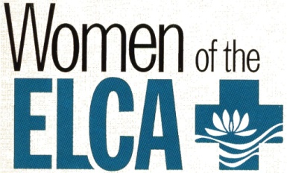
Florida-Bahamas Synodical Women’s Organization Scholarship

Name: Sex: Male Female
Last First MI

Permanent Address:
Address City State Zip

Current Phone Number: Email:

ELCA Seminary attending:
Note: Only those currently attending ELCA seminaries are eligible to be awarded this scholarship

Degree being sought: Master of Divinity (M. DIV) Master of Arts (MA)

Year in Seminary:

Home Congregation: Location:
Name City/State

Are you an active member of your Women of the ELCA Congregational Unit?

Describe your involvement:

Describe how you exhibit faith qualities that empower others:
(Attach separate sheet if needed)

How have you demonstrated leadership qualities in the church and community?
(Attach separate sheet if needed)

What additional information would you like to share regarding your application for scholarship? (Attach separate sheet if needed)

Please submit this completed application to Florida-Bahamas SWO President Tracy Moffatt at: 1944 Crestview Way, Naples, FL 34119 or to tracymoffatt@aol.com

Deadline for Submission – January 1, 2020

Direct any questions to Tracy at 239-597-8383 or tracymoffatt@aol.com

Applicants will be notified no later than April 30, 2020. Scholarships will be awarded in two increments (September and January) according to the guidelines of the ELCA Fund for Leaders in Mission. The selected applicant will be invited to attend our Fall Gathering scheduled November 2020, at Lake Yale Baptist Center in Leesburg, FL, or send a video or written greeting.

